Sweet Potato Biscuits
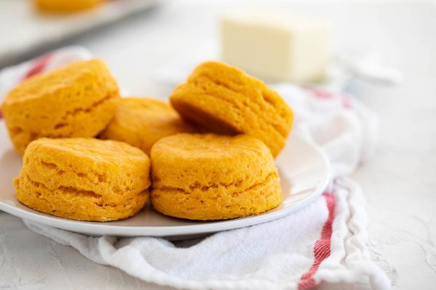

Eddie’s Note
I made these biscuits at home after tasting some at Unforgettable Food Affairs, when tasting foods for my daughter’s wedding. I am hooked on the sweet potato biscuits. I may continue to tweak the recipe to try and get them to be as good as what we tasted at the caterer’s, but hers were off the chart good. These are a very good start in that direction.

Ingredients
Makes 16 biscuits
- 2 ½ pounds sweet potatoes (4 to 5 medium)
- 2 tablespoons cider vinegar
- 3 ¼ cups cake flour (see note)
- ¼ cup packed dark brown sugar
- 5 teaspoons baking powder
- ½ teaspoon baking soda
- 1 ½ teaspoons salt
- 8 tablespoons (1 stick) unsalted butter, cut into 1/2-inch pieces and chilled; plus 2 tablespoons unsalted butter, melted
- 4 tablespoons vegetable shortening, cut into 1/2-inch pieces

Before You Begin
You can substitute a combination of 2 1/4 cups plus 3 tablespoons all-purpose flour and 7 tablespoons cornstarch for the cake flour. If you halve the recipe, in step 1 reduce the microwave time to 10 to 15 minutes.

Instructions
Microwave Potatoes
Prick potatoes all over with fork. Microwave on large plate until potatoes are very soft and surface is wet, 15 to 20 minutes, flipping every 5 minutes. Immediately slice potatoes in half to release steam. When cool enough to handle, scoop flesh into bowl and mash until smooth. (You should have 2 cups. Reserve any extra for another purpose.) Stir in vinegar and refrigerate until cool, about 15 minutes.
Make Dough
Adjust oven rack to middle position and heat oven to 425 degrees. Line rimmed baking sheet with parchment paper. Pulse flour, sugar, baking powder, baking soda, salt, chilled butter, and shortening in food processor until mixture resembles coarse meal. Transfer to bowl with cooled potatoes and fold with rubber spatula until incorporated.
Cut Biscuits
Turn dough out onto floured surface and knead until smooth, 8 to 10 times. Pat dough into 9-inch circle, about 1 inch thick. Using 2¼-inch biscuit cutter dipped in flour, cut out biscuits and arrange on prepared baking sheet. Pat remaining dough into 1-inch-thick circle and cut out remaining biscuits.
Bake Biscuits
Brush tops of biscuits with melted butter and bake until golden brown, 18 to 22 minutes. Let cool 15 minutes. Serve. (Biscuits can be stored at room temperature in an airtight container for 2 days.)

