Recipe of the Month : Seared Salmon with Baby Spinach
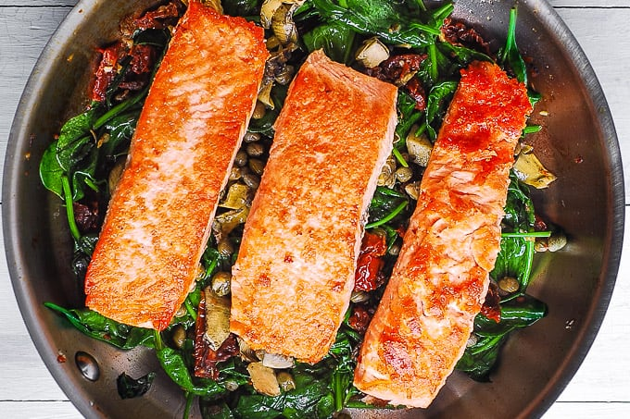
Eddie’s Note
Salmon is one of our favorite dinner dishes and here is a simple way to dress it up.

Ingredients
- 2 (7 oz.) skinless salmon fillets
- 2 tablespoons butter
- 3 large shallots, sliced
- 1 1/2 tablespoons chopped fresh tarragon
- 3 ounces baby spinach leaves
- 1/3 cup dry white wine
- 1/4 cup whipping cream

Instructions
Sprinkle salmon with salt and pepper. Melt 1 tablespoon butter in medium skillet over medium-high heat. Add salmon; saute until just opaque in center, about 4 minutes per side. Transfer to plate.
Melt 1/2 tablespoon butter in same skillet. Add half of shallots and half of tarragon; saute 30 seconds. Increase heat to high; add half of spinach and toss 30 seconds. Add remaining spinach; toss until wilted. Divide between plates.
Melt remaining 1/2 tablespoon butter in same skillet over medium- high heat. Add remaining shallots and tarragon; saute 30 seconds. Add wine and cream and boil until sauce is thick enough to coat spoon, about 3 minutes. Season with salt and pepper. Return salmon to skillet; simmer 1 minute. Arrange salmon with sauce atop spinach.

